

Multi Tenancy in Current Tazama System
TECHNICAL SPECIFICATIONS DOCUMENT

Version 1.0
22.04.2025
Document Information
Project | TAZAMA DEVELOPMENT
Document Title | Multi Tenancy in Current Tazama System
Prepared by | UME SAUDA GHANYANI – SENIOR BA @ PAYSYSLABS
Version Number | 1.0
Version Date | 19.06.2025

Document Revision History
Date | Author | Version | Change Reference
19.06.2025 | UME SAUDA GHANYANI | 1.0 | BASELINE VERSION SHARED WITH TAZAMA FOR REVIEW

Table of Contents
1. Introduction 3
1.1 Purpose 4
1.2 Scope of the Document 4
1.3 Intended Audience 4
1.4 References 4
2. Components Affected 4
3. TMS-Service Multi-Tenancy Implementation 5
3.1 Authentication Mechanism 6
Token Extraction and Validation: 6
Transaction Flow: 6
3.2 Sequence Diagram 6
4. Event-Director Multi-Tenancy Implementation 7
4.1 Network Map Adjustments 7
4.2 Network Map Structure 7
Existing Structure 7
Proposed Structure 8
4.3 Impact on Config Service 8
5. Rule Processor 9
Current Behavior 9
Proposed Change 9
Impact 9
6. Relay-Service Multi-Tenancy Implementation 10
6.1 Modifications to TADP and TP 10
6.2 Dedicated Relay Service per Tenant 10
7. Future Considerations 11
7.1 Data Ingestion and Processing – Future Design Options 12
8. Glossary 13

Introduction

Purpose
This document provides the necessary technical details for implementing multi-tenancy within the Tazama system. The goal is to make the Tazama platform capable of managing multiple tenants (or clients), each with its own isolated environment while using the same underlying infrastructure. This update involves several key components.

Scope of the Document
The changes outlined in this document are focused solely on the current Tazama system. Any newly developed modules are outside the scope at this stage.

Intended Audience
This document is intended for the development and technical teams responsible for the implementation of multi-tenancy in the existing Tazama system.

References
- Tazama multi-tenancy v1.0 20250220.docx (Shared by Justus)

Components Affected
- TMS-Service: The service responsible for handling transaction-related logic.
- Event-Director: The component responsible for managing event-driven flows and network configurations.
- Relay Service: The service that handles message routing for tenants.

TMS-Service Multi-Tenancy Implementation

Authentication Mechanism
The TMS-Service will interact with the auth-service to validate tokens and extract tenant-specific information.
Flow Overview:
- The FSP (Financial Service Provider) will first fetch a token from the auth-service.
This token must be validated on each route using middleware functions defined in the auth-lib.
- The token will contain a tenant identifier (tenant-id), which should be extracted and processed.
- If embedding the tenant-id within the token is not feasible, the tenant-id must be sent in the request payload for each transaction.
Token Extraction and Validation:
- The auth-lib will provide functionality to decode the token and extract the tenant ID.
- This logic will be implemented as middleware that checks each route for a valid token.
- In cases where the tenant-id is not embedded in the token, the tenant-id will be manually attached to the request payload for validation.
Transaction Flow:
- After successful token validation, the tenant-id will be appended to the transaction object and forwarded to the downstream flow in the logic.service.
- This will ensure that all subsequent transaction processing is properly scoped to the correct tenant.

Sequence Diagram
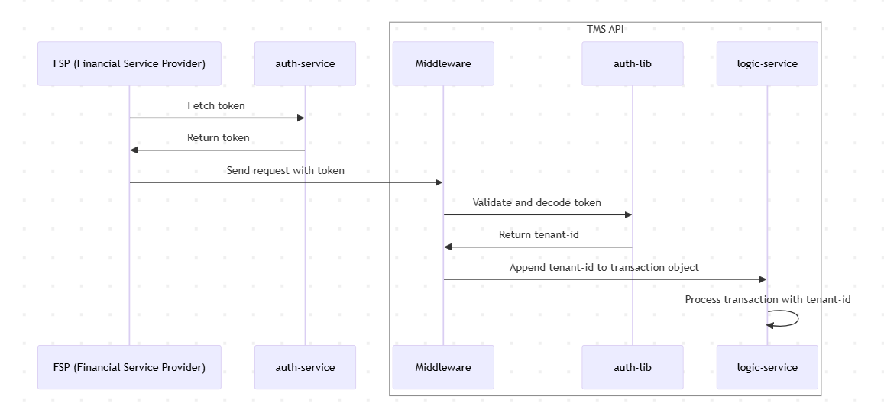

Event-Director Multi-Tenancy Implementation

Network Map Adjustments
The Event-Director currently loads the Network Map structure from the database layer. With multi-tenancy, the structure of the Network Map will need to be adjusted to incorporate tenant-specific data.

Network Map Structure

Existing Structure

"networkMap": {
"active": true,
"cfg": "1.0.0",
"messages": [
{
"id": "004@1.0.0",
"cfg": "1.0.0",
"txTp": "pacs.002.001.12",
"typologies": [
{
"id": "typology-processor@1.0.0",
"cfg": "999@1.0.0",
"rules": [
{
"id": "EFRuP@1.0.0",
"cfg": "none"
},
{
"id": "901@1.0.0",
"cfg": "1.0.0"
}
]
}
]
}
]
}

Proposed Structure

"networkMap": {
"active": true,
"cfg": "1.0.0",
"tenants": [
"tenant-id": "tenant-id",
"tenant-name": "name"
"messages": [
{
"id": "004@1.0.0",
"cfg": "1.0.0",
"txTp": "pacs.002.001.12",
"typologies": [
{
"id": "typology-processor@1.0.0",
"cfg": "999@1.0.0",
"rules": [
{
"id": "EFRuP@1.0.0",
"cfg": "none"
},
{
"id": "901@1.0.0",
"cfg": "1.0.0"
}
]
}
]
}
]
]
}

Impact on Config Service
The Config-Service will need to support the new multi-tenant structure by querying and updating tenant-specific configurations. The existing system will need to be updated to handle the tenant-specific data in the networkMap.

Rule Processor
Current Behavior
Tazama currently caches the most recent rule configuration for evaluation purposes.
Proposed Change
Rather than disabling rule caching, we will load and cache the most recent rule configuration for each tenant individually. This ensures that each tenant's rule set is kept isolated and up to date while maintaining the performance benefits of caching.

Impact
The system will cache the most recent rule configuration per tenant, improving processing efficiency without compromising tenant-specific configurations.

Relay-Service Multi-Tenancy Implementation

Modifications to TADP and TP
Each relay service will route messages only for its designated tenant, ensuring isolation between tenants. The `TADP` and `TP` need to be able to write to multiple tenant specific NATS subjects, on which a tenant specific relay-service is running.

Dedicated Relay Service per Tenant
Each tenant will have its own dedicated relay service to manage message routing independently. This ensures that tenant-specific messages are processed separately and do not overlap with other tenants' messages.

Future Considerations

7.1 Data Ingestion and Processing – Future Design Options
- Current Status:
Data ingestion and processing are not part of the current implementation. However, these will need to be addressed in future updates as part of the overall system design.
- Considerations for Future Implementation:
To manage data visibility between tenants, three potential models have been considered:
  - Global Access: All tenants have the ability to view and access data, creating a shared environment.
  - Tenant Isolation: Data is isolated, allowing only the respective tenants to access their own data. This ensures complete separation between tenants’ information.
  - Selective Sharing: Some tenants are granted access to specific datasets, based on predefined rules or permissions. This allows for more flexible data sharing while maintaining a level of control over what data can be seen by each tenant.
- Next Steps:
Further discussions and planning will be required to determine the best model for data visibility, ensuring it aligns with both security and functional requirements.

Glossary

ED: Event Director
TMS: Transaction Monitoring System

